Council of the Great City Schools
Annual Academic, Information Technology,
and Research Conference

for

Information Technology Leaders, Curriculum Leaders, Research and Assessment Directors, Principal Supervisors
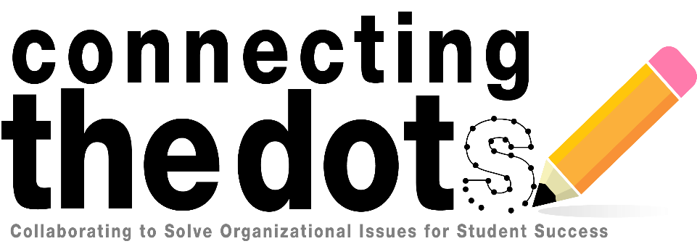
July 11-14, 2017
Pittsburgh, PA
Omni William Penn Hotel

The Council of the Great City Schools invites you to the Second Annual Academic, Information Technology, and Research Conference. The focus of this year’s conference is overcoming organizational issues in order to improve student success. We are building upon previous work that focused on improving collaboration across departments and roles within school districts. Throughout the conference, you will have a chance to hear from peers who are developing promising practices and strategies for success. Woven throughout the conference will be opportunities to synthesize concrete actions to help your district. The meeting will include an in-depth update on the status of ESSA implications for members. There will also be role-alike concurrent sessions that provide thorough discussions of specific technology, data dashboard repositories, ESSA benchmarking, the features of quality district curriculum support, key areas that are often missing from reading programs, new CGCS on-line professional development modules to address struggling readers, and planning for a K-12 computer science program. We encourage districts to bring cross departmental teams that include: informational technology leaders, academic leaders, research and assessment leaders, principal supervisors, and others in these functional areas.

Preliminary Conference Agenda

Tuesday, July 11, 2017, 7:00AM – 5:00PM
7:00AM – 8:00 AM |  | Breakfast
8:00AM – 8:30 AM |  | Welcome, Agenda Overview and “Connecting the Dots”
8:30AM-12:00PM |  | Joint Plenary/District Presentations
12:00PM – 1:00PM |  | Lunch
1:30PM – 5:00PM |  | Concurrent Sessions/District Presentations
6:00PM – 8:00PM |  | Reception at the Andy Warhol Museum (hotel pick up @ 5:30PM)
Wednesday, July 12, 2017, 7:00AM – 5:00PM
7:00AM – 8:00AM |  | Breakfast
8:00AM – 12:00PM |  | Concurrent Sessions/District Presentations
12:15PM – 1:15PM |  | Lunch
1:30PM – 5:00PM |  | Concurrent Sessions/District Presentations/Legislative Update
5:00PM – 6:30PM |  | CIO Awards Reception
Thursday, July 13, 2017, 7:00AM – 5:00PM
7:00AM – 8:00AM |  | Breakfast
8:00AM – 10:00AM |  | General Session “Connecting the Dots” – (Jesus Jara, Deputy Superintendent, Michael Eugene, Chief Operating Officer, and Barbara Jenkins (TBD), Orange County Public Schools,
10:15AM – 12:00PM |  | Share Out & Reflection (PCG Facilitator)
12:00PM – 1:30PM |  | Lunch
1:30PM –3:00PM |  | Panel Discussion (PCG Facilitator)
3:30PM – 5:00PM |  | Reflection Discussion (PCG Facilitator)
Friday, July 14, 2017, 8:00AM – 12:00PM
7:00AM – 8:15AM |  | Breakfast
8:30AM – 12:00PM |  | Concurrent Sessions/District Presentations
12:00PM |  | Adjourn

